Association is a relation between two separate classes which establishes through their Objects. Association can be one-to-one, one-to-many, many-to-one, many-to-many. In Object-Oriented programming, an Object communicates to another object to use functionality and services provided by that object. Composition and Aggregation are the two forms of association.

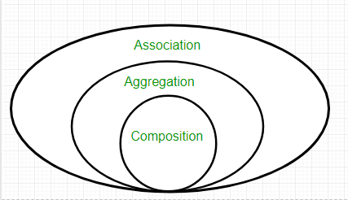

Aggregation is a specialized form of Association where all objects have their own lifecycle but there is ownership and child object cannot belong to another parent object. Let’s take an example of Department and teacher. A single teacher cannot belong to multiple departments, but if we delete the department object, teacher object will not be destroyed.

Composition
Here Child object does not have its own lifecycle and if parent object dies all the children will die. Let’s take again an example of relationship between House and rooms. House can contain multiple rooms. If we delete the house, room/rooms will automatically die. Let’s take another example relationship between Questions and options. Single question can have multiple options and if we delete question, options will automatically be deleted.

